# [**NBC Fall Schedule: 'The Voice' & 'Superstore' Are Back, But What's Held for 2021?**](https://www.tvinsider.com/946879/nbc-fall-2020-schedule-the-voice-superstore-blacklist/)

[***Meredith Jacobs***](https://www.tvinsider.com/author/meredith-jacobs/)AUGUST 27, 3:00 PM



Trae Patton/NBC; Eddy Chen/NBC

Your favorite NBC series are coming back this fall, just a bit later than usual.

The network announced its fall schedule Thursday, and most shows have simply been delayed by a month or two (due to the coronavirus pandemic). In September, viewers can tune in for the previously announced Canadian import [***Transplant***](https://www.tvinsider.com/show/transplant/) and [***American Ninja Warrior***](https://www.tvinsider.com/show/american-ninja-warrior/), as well as the debut of the *Weakest Link* revival with host Jane Lynch.

October will see the returns of [***The Voice***](https://www.tvinsider.com/show/the-voice/), with coaches [**Kelly Clarkson**](https://www.tvinsider.com/people/kelly-clarkson/), [**John Legend**](https://www.tvinsider.com/people/john-legend/), [**Blake Shelton**](https://www.tvinsider.com/people/blake-shelton/), and [**Gwen Stefani**](https://www.tvinsider.com/people/gwen-stefani/) and host Carson Daly, and [***Superstore***](https://www.tvinsider.com/show/superstore/). Plus, the new series, *Connecting...*, from [***Blindspot*'s**](https://www.tvinsider.com/show/blindspot/) Martin Gero, will debut. This comedy follows "a group of friends trying to stay close (and sane) through video chats as they share the highs and lows of these extraordinary times."

In addition to popular dramas [***This Is Us***](https://www.tvinsider.com/show/this-is-us/), the [**One Chicago**](https://www.tvinsider.com/show/one-chicago/) franchise, and [***Law & Order: SVU***](https://www.tvinsider.com/show/law-order-svu/), November will see the return of [***The Blacklist***](https://www.tvinsider.com/show/the-blacklist/).



*The Blacklist* (Virginia Sherwood/NBC)

[***Brooklyn Nine-Nine***](https://www.tvinsider.com/show/brooklyn-nine-nine/), [***Good Girls***](https://www.tvinsider.com/show/good-girls/), [***Making It***](https://www.tvinsider.com/show/making-it/), [***Manifest***](https://www.tvinsider.com/show/manifest/), [***New Amsterdam***](https://www.tvinsider.com/show/new-amsterdam/), and [***Zoey's Extraordinary Playlist***](https://www.tvinsider.com/show/zoeys-extraordinary-playlist/) are all set to return in 2021. New series debuting next year include *Kenan*, [***Law & Order: Organized Crime***](https://www.tvinsider.com/show/law-order-organized-crime/), *Mr. Mayor*, *That's My Jam*, *Small Fortune*, *True Story*, *Who Do You Think You Are?* and *Young Rock*.

Check out NBC's fall schedule below. (All shows, except NBC Sunday Night Football and *The Voice*, will be available on NBCUniversal's streaming service, Peacock.)

### **Tuesday, September 1**

**10 p.m.:** *Transplant*

### **Monday, September 7**

**8:00-10:00 p.m.:** *American Ninja Warrior*

[SEE ALSO](https://www.tvinsider.com/945106/american-ninja-warrior-season-12-premiere-date/)

### [**'American Ninja Warrior' Sets Two-Hour Season 12 Premiere at NBC**](https://www.tvinsider.com/945106/american-ninja-warrior-season-12-premiere-date/)

Find out when the reality competition series returns this fall.

### **Thursday, September 10**

**5:20 p.m.:** NBC Sunday Night Football

### **Sunday, September 13**

**5:20 p.m.:** NBC Sunday Night Football

### **Friday, September 25**

**10 p.m.:** *Dateline NBC*

### **Tuesday, September 29**

**8 p.m.:** *Weakest Link*

### **Thursday, October 1**

**8:30 p.m.:** *Connecting …*

### **Tuesday, October 6**

**8:00-10:00 p.m.:** *Ellen's Game of Games*

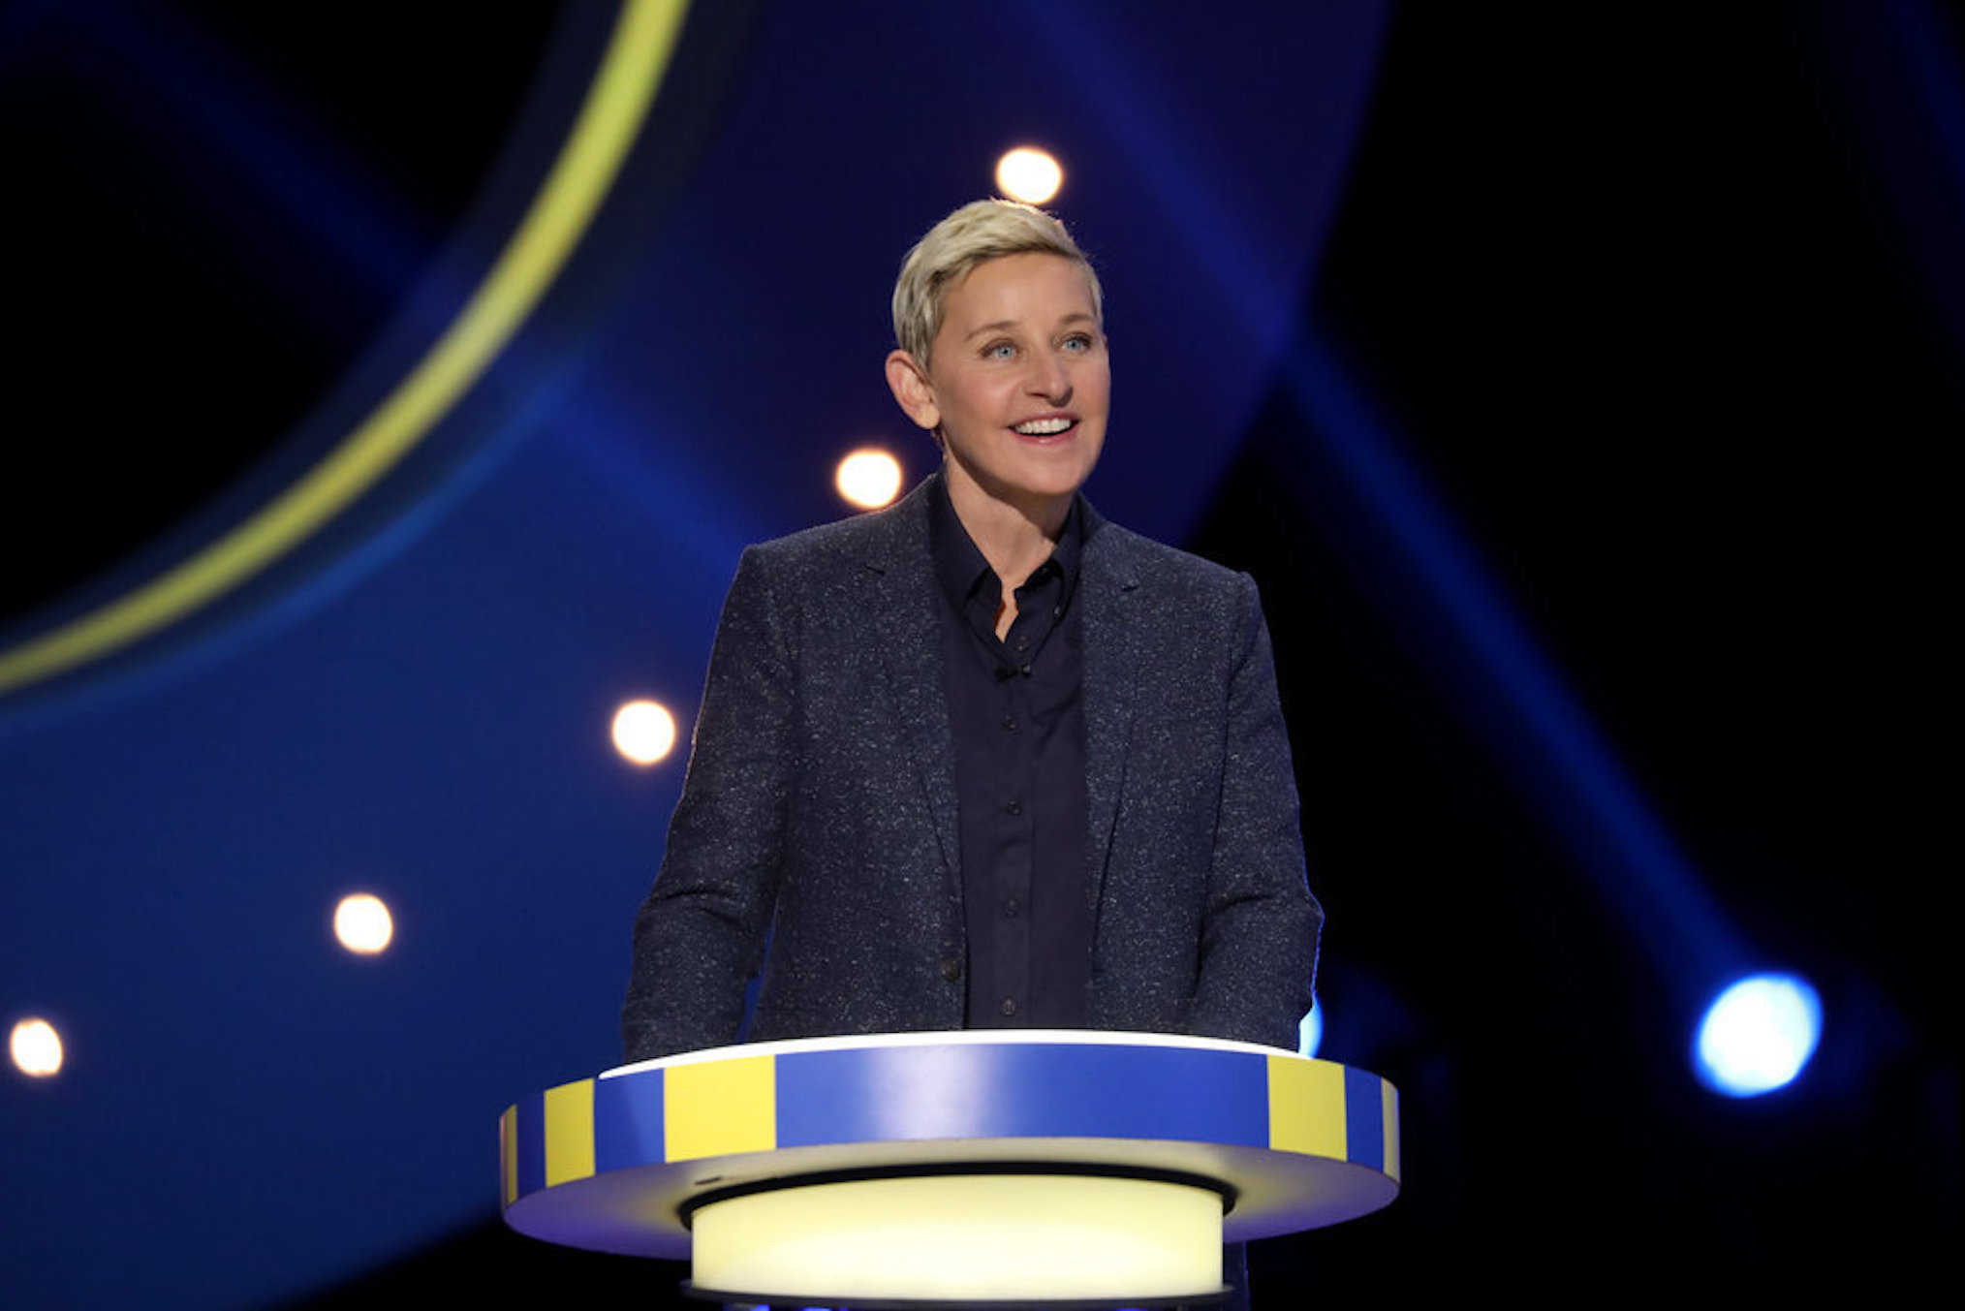

*Ellen's Game of Games* (Mike Rozman/Warner Brothers/NBC)

### **Tuesday, October 13**

**9:00 p.m.:** *Ellen's Game of Games* (Regular Time Period)

### **Monday, October 19**

**8:00-10:00 p.m.:** *The Voice*

### **Tuesday, October 20**

**8:00-10:00 p.m.:** *The Voice*

### **Thursday, October 22**

**8:00 p.m.:** *Superstore*

### **Tuesday, October 27**

**8:00-9:00 p.m.:** *The Voice* (Regular Time Period)

### **Tuesday, November 10**

**9:00-11:00 p.m.:** *This Is Us*

### **Wednesday, November 11**

**8:00 p.m.:** *Chicago Med*

**9:00 p.m.:** *Chicago Fire*

[SEE ALSO](https://www.tvinsider.com/gallery/chicago-fire-pd-med-new-characters-2020/)

### [**6 New Characters We'd Like to See Across One Chicago Next Season**](https://www.tvinsider.com/gallery/chicago-fire-pd-med-new-characters-2020/)

It's time to add some fresh blood across the board.

**10:00 p.m.:** *Chicago P.D.*

### **Thursday, November 12**

**9:00 p.m.:** *Law & Order: SVU*

### **Friday, November 13**

**8:00 p.m.:** *The Blacklist*

### **Tuesday, November 17**

**9:00 p.m.:** *This Is Us* (Regular Time Period)